Golden_Gate_Deployment_ with ORM stack

Contents

1. Introduction 3
2. Workflow diagram to deploy the stack 3
3. Create stack for Golden gate deployment 4
4. Plan the Job 8

Introduction

Deployments create and organize Oracle Cloud Infrastructure GoldenGate resources, and enables the OCI GoldenGate deployment console, add and manage data replication processes. create deployments for Oracle Database, Big Data, Microsoft SQL Server, MySQL, and PostgreSQL sources or targets.

Workflow diagram to deploy the stack

Below diagram shows how the Terraform Artifact are applied in the OCI. While creating a ORM stack, using terraform deliverables Init, Plan and Apply is the flow to provision the resource in the OCI. We can have the deliverables in any of below.

- GitLab/GitHub Repo
- Bitbucket
- Can be in folder/.zip in the local disk
- Object Storage Bucket
- Can be in compartment
- Oracle provided Template


Create stack for Golden gate deployment

Go to OCI Console Developer Services Resource Manager Stacks select the compartment Create Stack

My Configuration Folder Browse Select the “golden_gate_deployment” folder that contains the terraform Upload

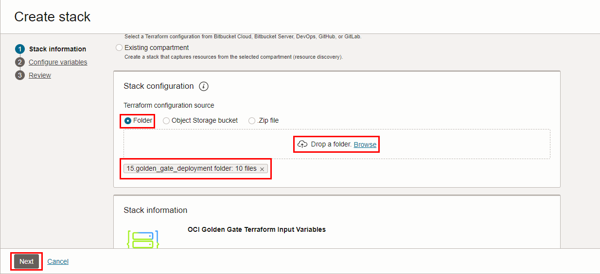

Select the parameters as per the below screen,
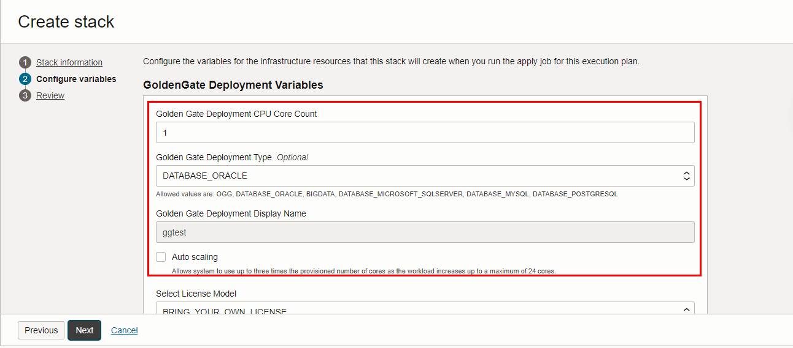

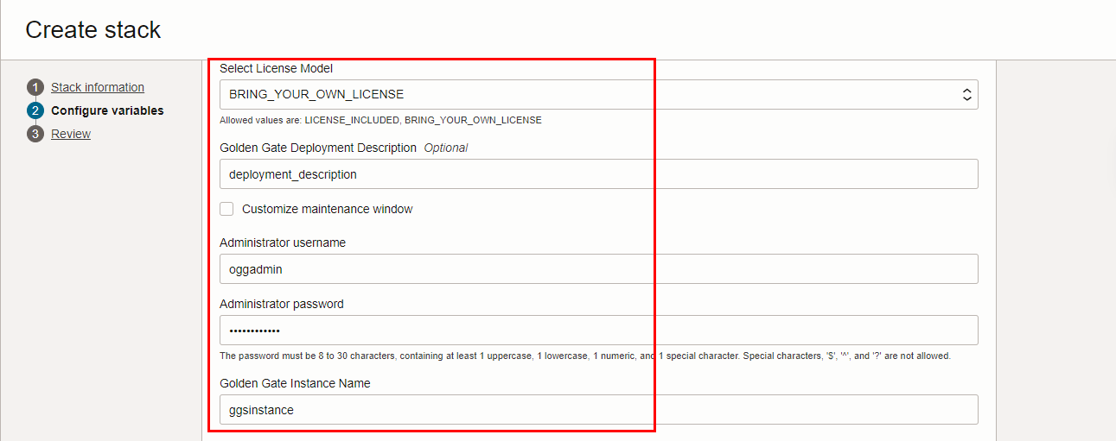

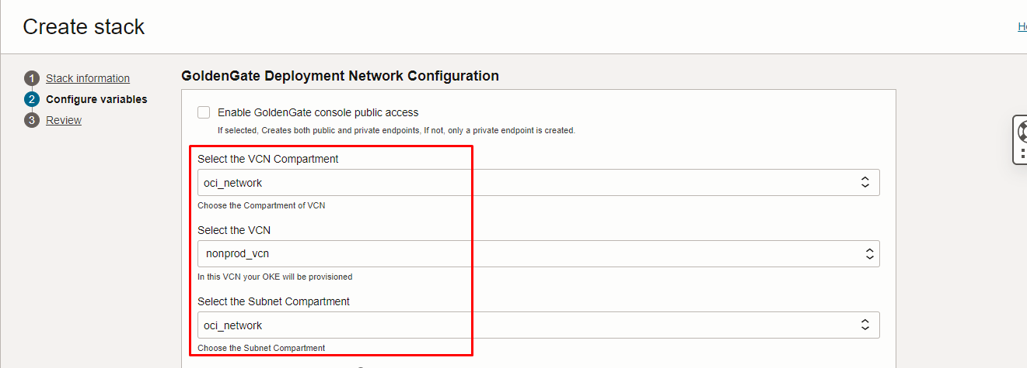

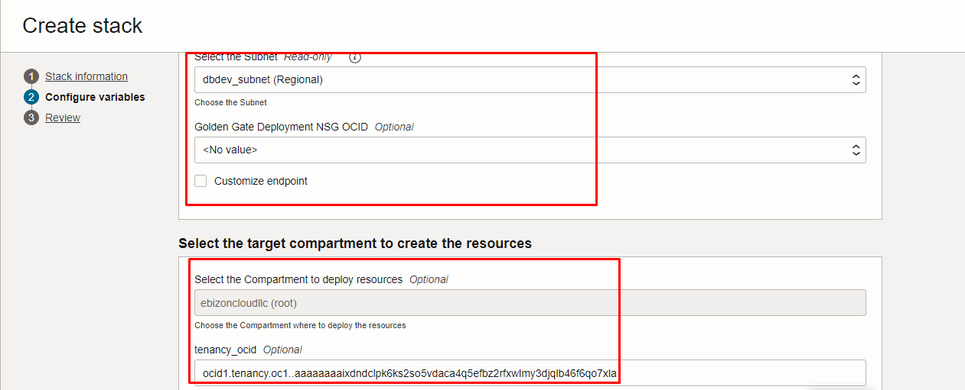

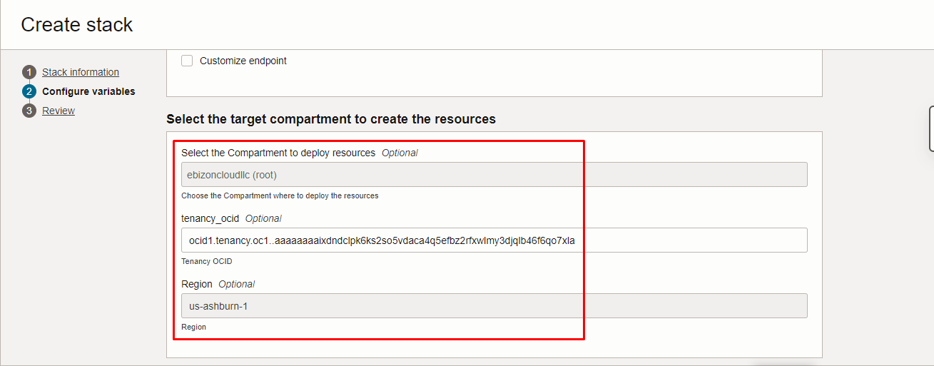

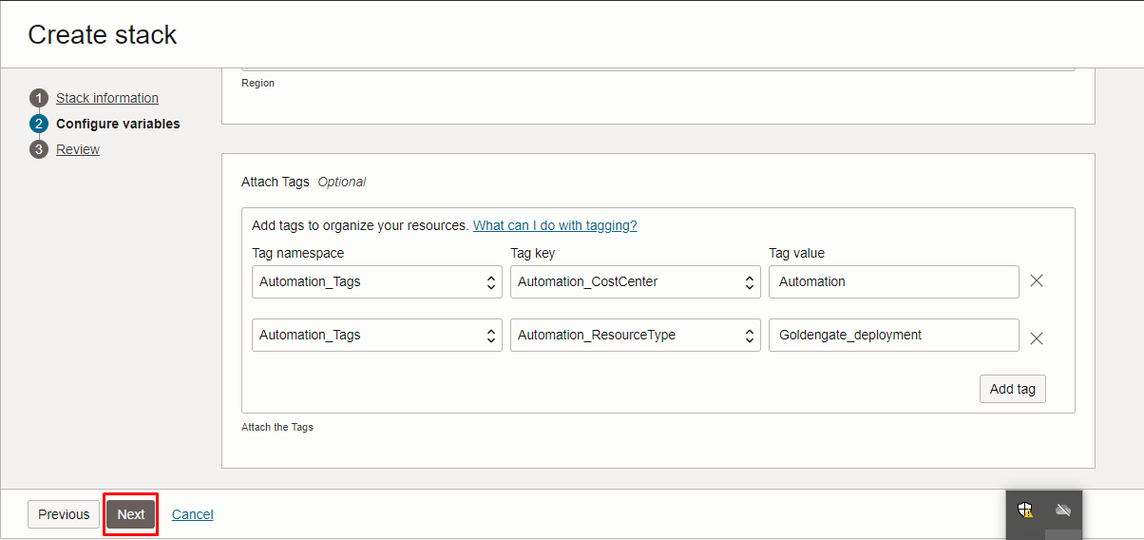
Click “NEXT”

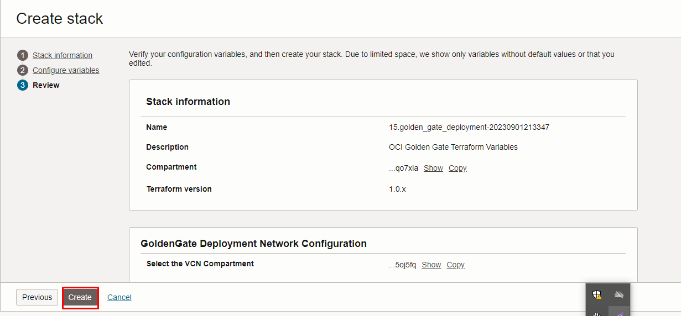
Click “CREATE”

Plan the Job

Click the “Plan”
